613-23 guruh Taabasi \ Nomozov Mahmudjon

1. Topshiriq

Bot yaratilish jarayoni va uni izohlar bilan screen shoti (bot silkasi yashil 24 shrifda)

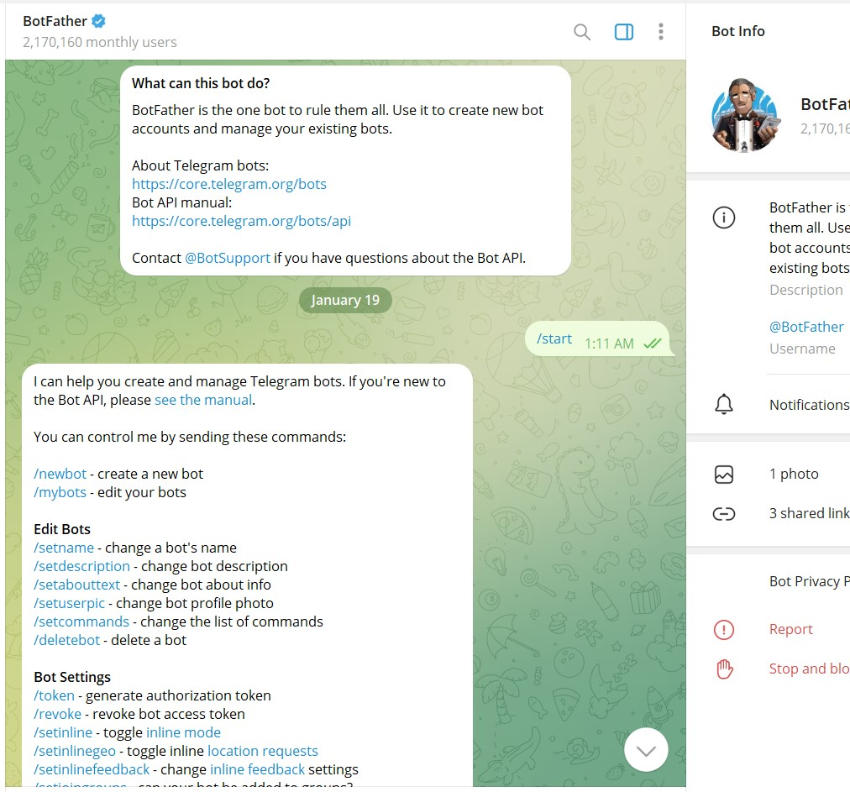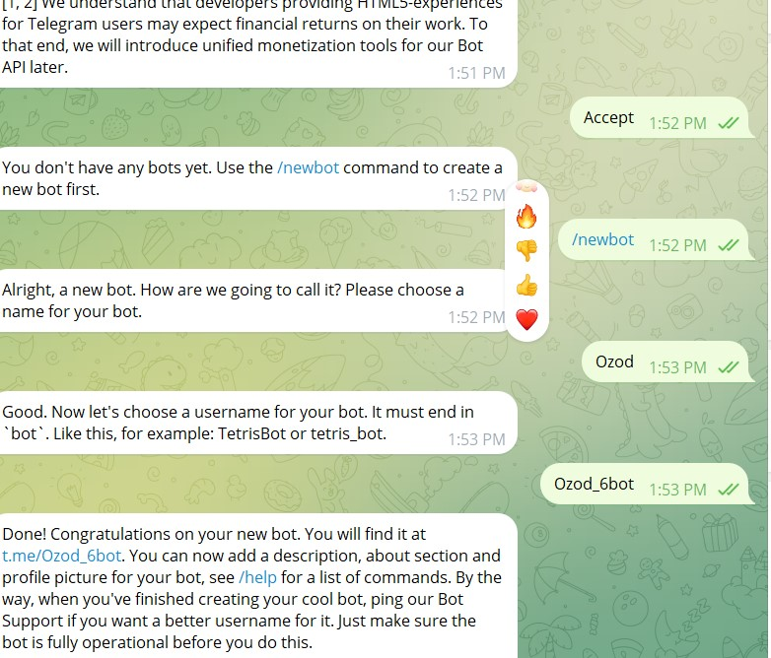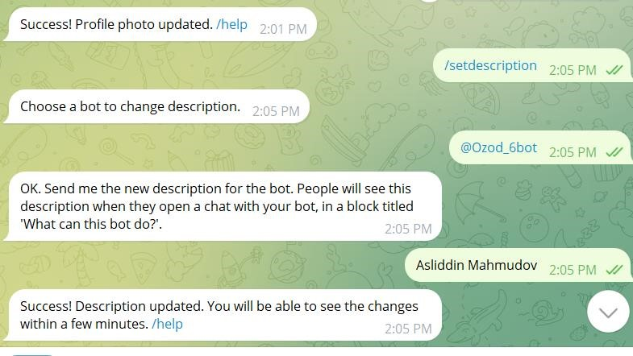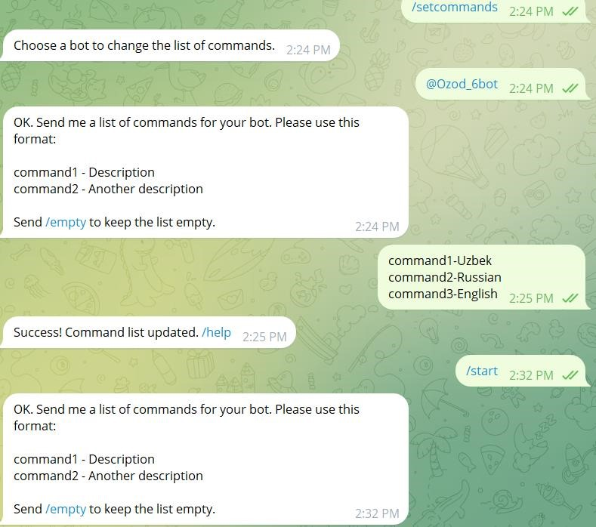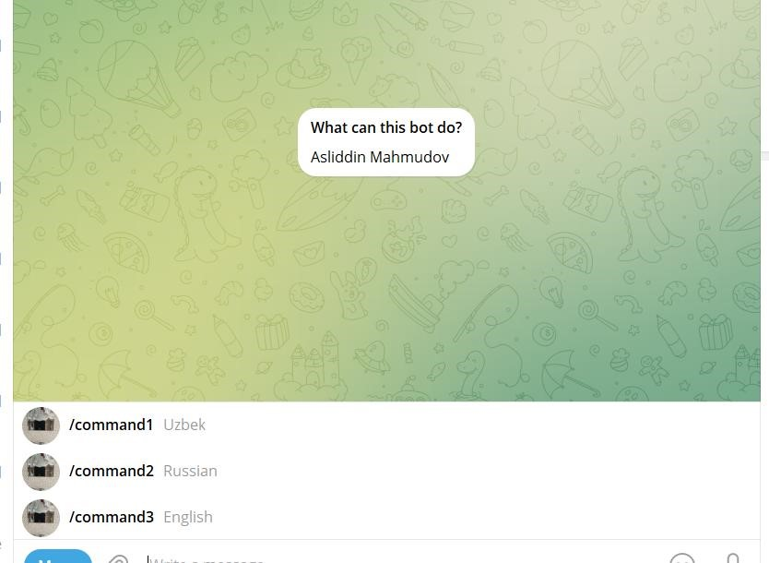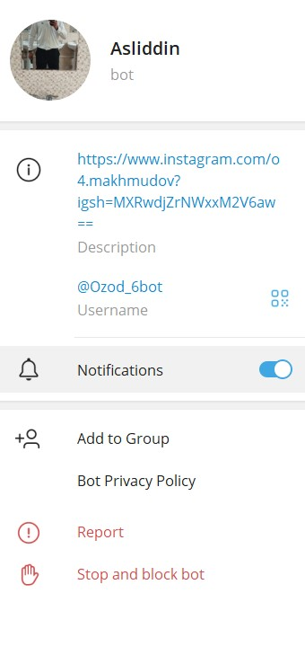

1. Topshiriq

Teachable machineda ma’lumotlar tahlili va dastur kodi

613-23 GURUH Talabasi Mahmudov Asliddin \

<div>Teachable Machine Image Model</div>

<button type="button" onclick="init()">Start</button>

<div id="webcam-container"></div>

<div id="label-container"></div>

<script src="https://cdn.jsdelivr.net/npm/@tensorflow/tfjs@latest/dist/tf.min.js"></script>

<script src="https://cdn.jsdelivr.net/npm/@teachablemachine/image@latest/dist/teachable machine-image.min.js"></script> <script type="text/javascript"> // More API functions here:

// https://github.com/googlecreativelab/teachablemachine- community/tree/master/libraries/image

// the link to your model provided by Teachable Machine export panel const URL = "./my_model/";

let model, webcam, labelContainer, maxPredictions;

// Load the image model and setup the webcam async function init() { const modelURL = URL + "model.json"; const metadataURL = URL + "metadata.json";

// load the model and metadata

// Refer to tmImage.loadFromFiles() in the API to support files from a file picker

// or files from your local hard drive

// Note: the pose library adds "tmImage" object to your window

(window.tmImage) model = await tmImage.load(modelURL,

metadataURL); maxPredictions = model.getTotalClasses();

// Convenience function to setup a webcam const flip = true; // whether to flip the webcam webcam = new tmImage.Webcam(200, 200, flip);

// width, height, flip await webcam.setup(); // request access to the webcam await webcam.play(); window.requestAnimationFrame(loop);

// append elements to the DOM

document.getElementById("webcam-

container").appendChild(webcam.canvas); labelContainer = document.getElementById("label-container"); for (let i = 0; i < maxPredictions;

i++) { // and class labels

labelContainer.appendChild(document.createElement("div"));

} }

async function loop() {

webcam.update(); // update the webcam frame await predict();

window.requestAnimationFrame(loop);

}

// run the webcam image through the image model

async function predict() {

// predict can take in an image, video or canvas html element const prediction = await model.predict(webcam.canvas); for (let i = 0; i < maxPredictions; i++) { const classPrediction =

prediction[i].className + ": " +

prediction[i].probability.toFixed(2);

labelContainer.childNodes[i].innerHTML = classPrediction;

}

}

</script>

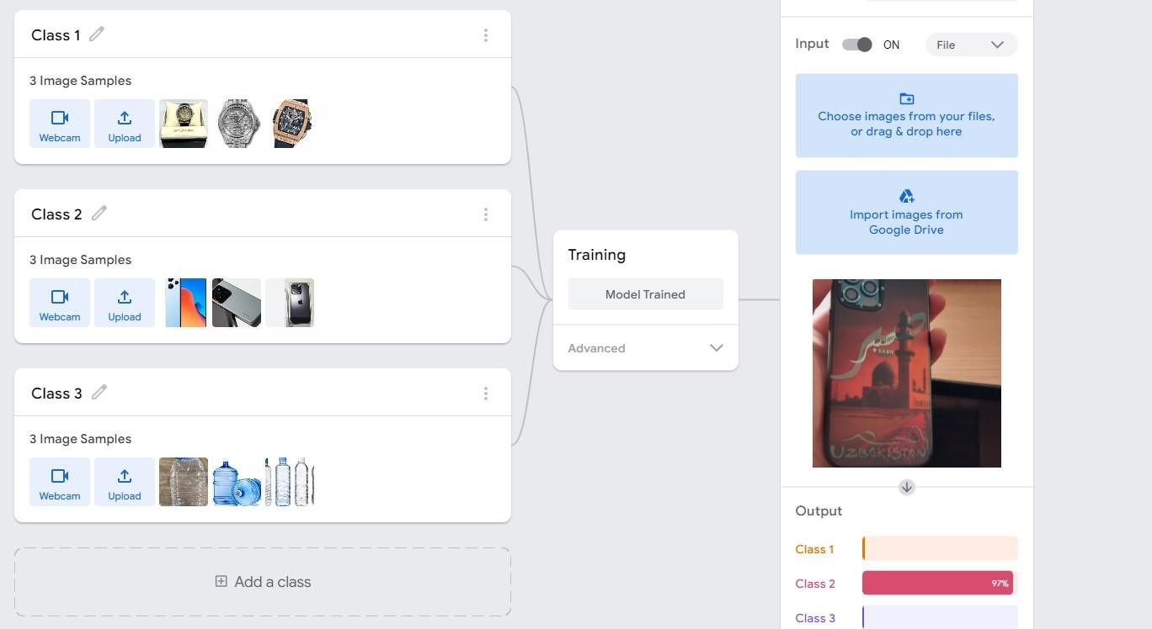

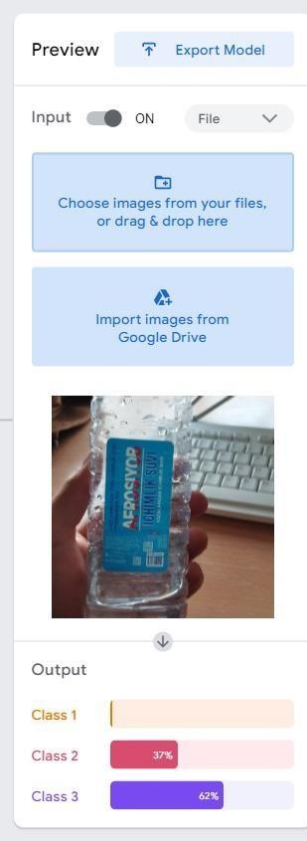

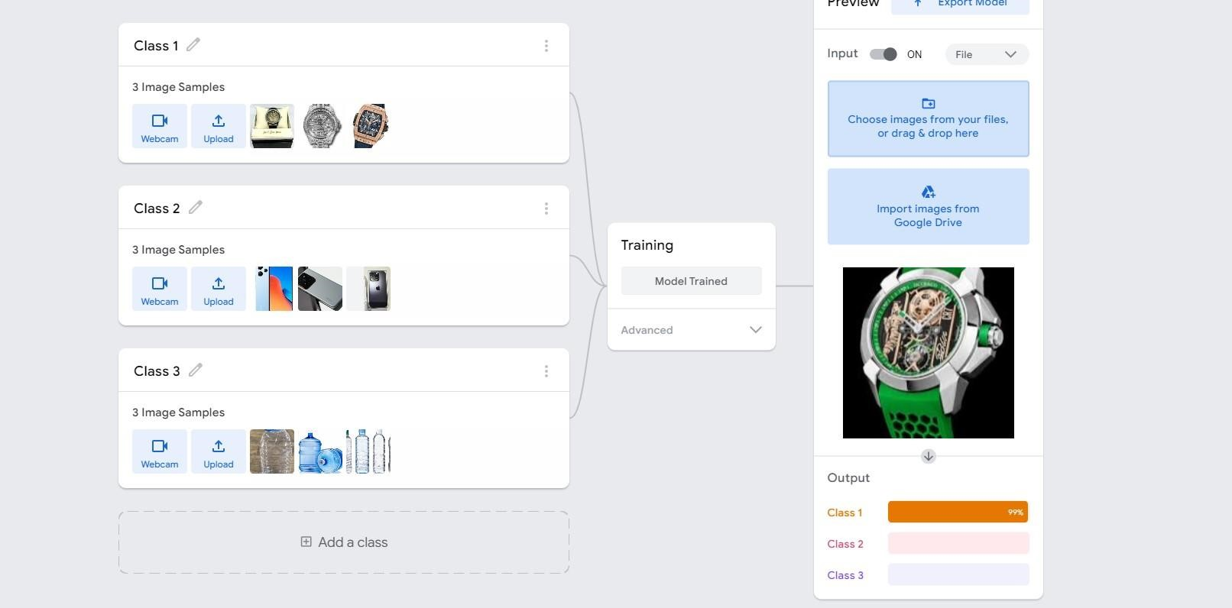

<div>Teachable Machine Image Model</div>

<button type="button" onclick="init()">Start</button>

<div id="webcam-container"></div>

<div id="label-container"></div>

<script src="https://cdn.jsdelivr.net/npm/@tensorflow/tfjs@latest/dist/tf.min.js"></script>

<script src="https://cdn.jsdelivr.net/npm/@teachablemachine/image@latest/dist/teachable machine-image.min.js"></script> <script type="text/javascript"> // More API functions here:

// https://github.com/googlecreativelab/teachablemachine- community/tree/master/libraries/image

// the link to your model provided by Teachable Machine export panel const URL = "./my_model/";

let model, webcam, labelContainer, maxPredictions;

// Load the image model and setup the webcam async function init() { const modelURL = URL + "model.json"; const metadataURL = URL + "metadata.json";

// load the model and metadata

// Refer to tmImage.loadFromFiles() in the API to support files from a file picker

// or files from your local hard drive

// Note: the pose library adds "tmImage" object to your window

(window.tmImage) model = await tmImage.load(modelURL,

metadataURL); maxPredictions = model.getTotalClasses();

// Convenience function to setup a webcam const flip = true; // whether to flip the webcam webcam = new tmImage.Webcam(200, 200, flip); // width, height, flip await webcam.setup(); // request access to the webcam await webcam.play(); window.requestAnimationFrame(loop);

// append elements to the DOM

document.getElementById("webcam- container").appendChild(webcam.canvas); labelContainer = document.getElementById("label-container"); for (let i = 0; i < maxPredictions;

i++) { // and class labels

labelContainer.appendChild(document.createElement("div"));

}

}

async function loop() { webcam.update(); // update the webcam frame

await predict(); window.requestAnimationFrame(loop);

}

// run the webcam image through the image model

async function predict() {

// predict can take in an image, video or canvas html element const prediction = await model.predict(webcam.canvas); for (let i = 0; i < maxPredictions; i++) { const classPrediction =

prediction[i].className + ": " +

prediction[i].probability.toFixed(2);

labelContainer.childNodes[i].innerHTML = classPrediction;

}

}

</script>

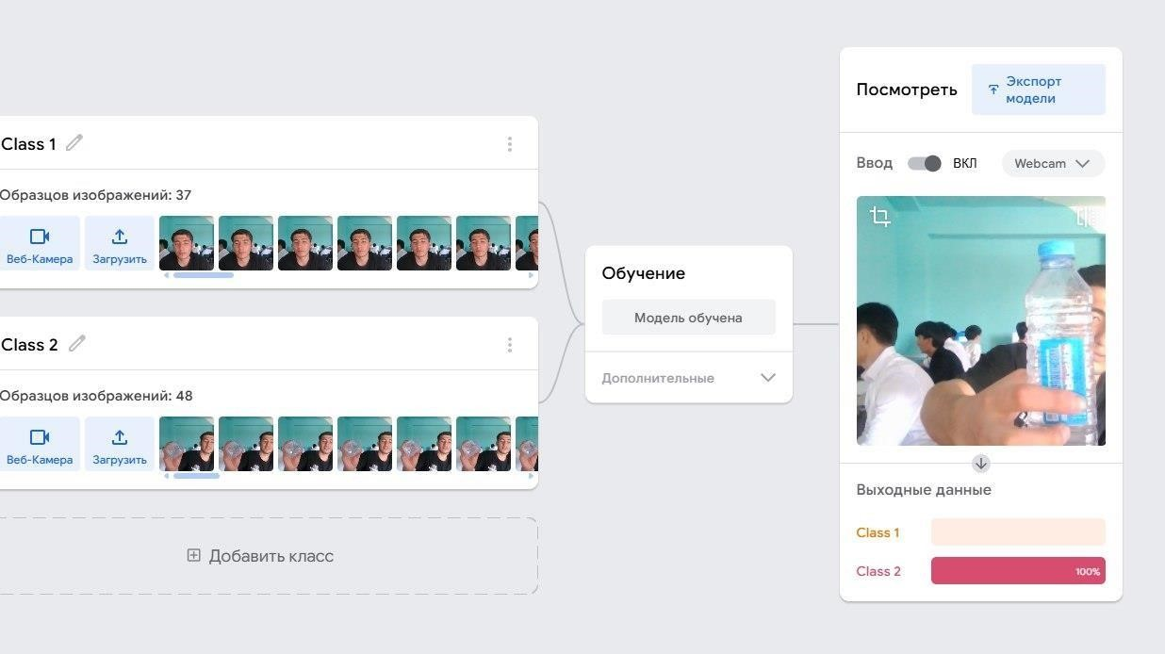



<div>Teachable Machine Image Model</div>

<button type="button" onclick="init()">Start</button>

<div id="webcam-container"></div>

<div id="label-container"></div>

<script src="https://cdn.jsdelivr.net/npm/@tensorflow/tfjs@latest/dist/tf.min.js"></script>

<script src="https://cdn.jsdelivr.net/npm/@teachablemachine/image@latest/dist/teachable machine-image.min.js"></script> <script type="text/javascript"> // More API functions here:

// https://github.com/googlecreativelab/teachablemachine- community/tree/master/libraries/image

// the link to your model provided by Teachable Machine export panel const URL = "./my_model/";

let model, webcam, labelContainer, maxPredictions;

// Load the image model and setup the webcam async function init() { const modelURL = URL + "model.json"; const metadataURL = URL + "metadata.json";

// load the model and metadata

// Refer to tmImage.loadFromFiles() in the API to support files from a file picker

// or files from your local hard drive

// Note: the pose library adds "tmImage" object to your window

(window.tmImage) model = await tmImage.load(modelURL,

metadataURL); maxPredictions = model.getTotalClasses();

// Convenience function to setup a webcam const flip = true; // whether to flip the webcam webcam = new tmImage.Webcam(200, 200, flip); // width, height, flip await webcam.setup(); // request access to the webcam await webcam.play(); window.requestAnimationFrame(loop);

// append elements to the DOM

document.getElementById("webcam- container").appendChild(webcam.canvas); labelContainer = document.getElementById("label-container"); for (let i = 0; i < maxPredictions;

i++) { // and class labels

labelContainer.appendChild(document.createElement("div"));

} }

async function loop() {

webcam.update(); // update the webcam frame await predict();

window.requestAnimationFrame(loop);

}

// run the webcam image through the image model

async function predict() {

// predict can take in an image, video or canvas html element const prediction = await model.predict(webcam.canvas); for (let i = 0; i < maxPredictions; i++) { const classPrediction =

prediction[i].className + ": " + prediction[i].probability.toFixed(2);

labelContainer.childNodes[i].innerHTML = classPrediction;

}

}

</script>

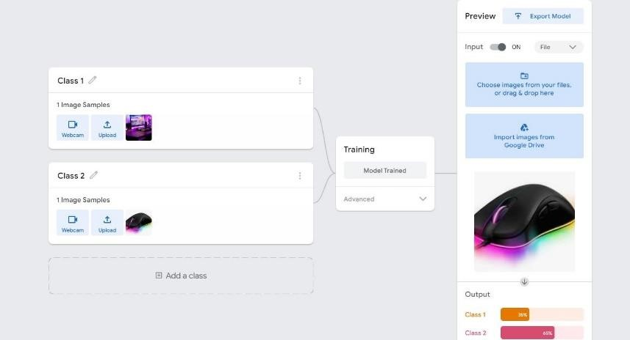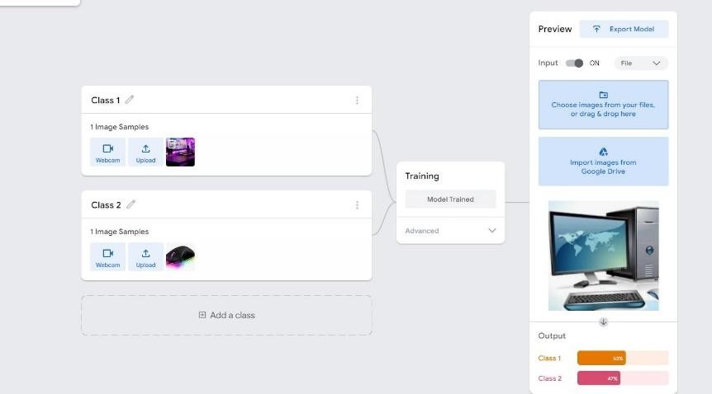

3-topshiriq

4 topshiriq

Pandas va numpy kutubhonasi google colabda aks ettirish va github ga joylash

